Install mysql installer community msi
Last update: Mar 26, 2022
https://www.onlinetutorialspoint.com/mysql/install-mysql-on-windows-10-step-by-step.html
https://mid.as/kb/00145/install-configure-mysql-on-windows

- Go to https://dev.mysql.com/downloads/mysql/
- Select “Microsoft Windows”.
- Download mysql-installer-community-8.0.22.0.msi (405.2M) (choose the latest version)
(This version can be install offline. Use the web-community version when install online)
- When ask to login, click “No thanks, just start my download”.
- Double click downloaded file to install. mysql-installer-community-8.0.22.0.msi
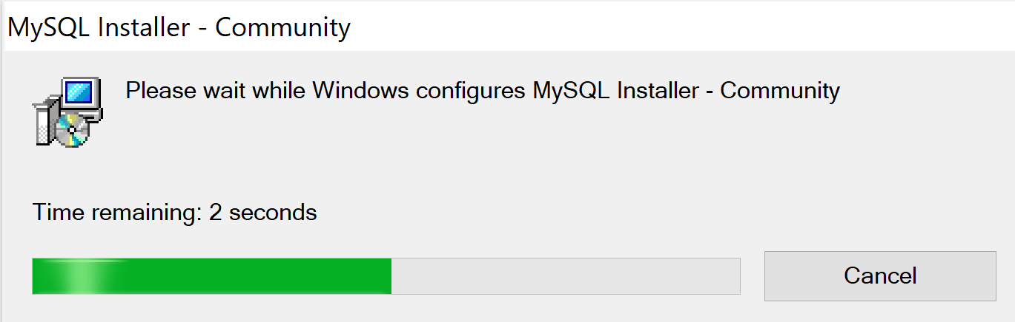
- Select “Server only”.

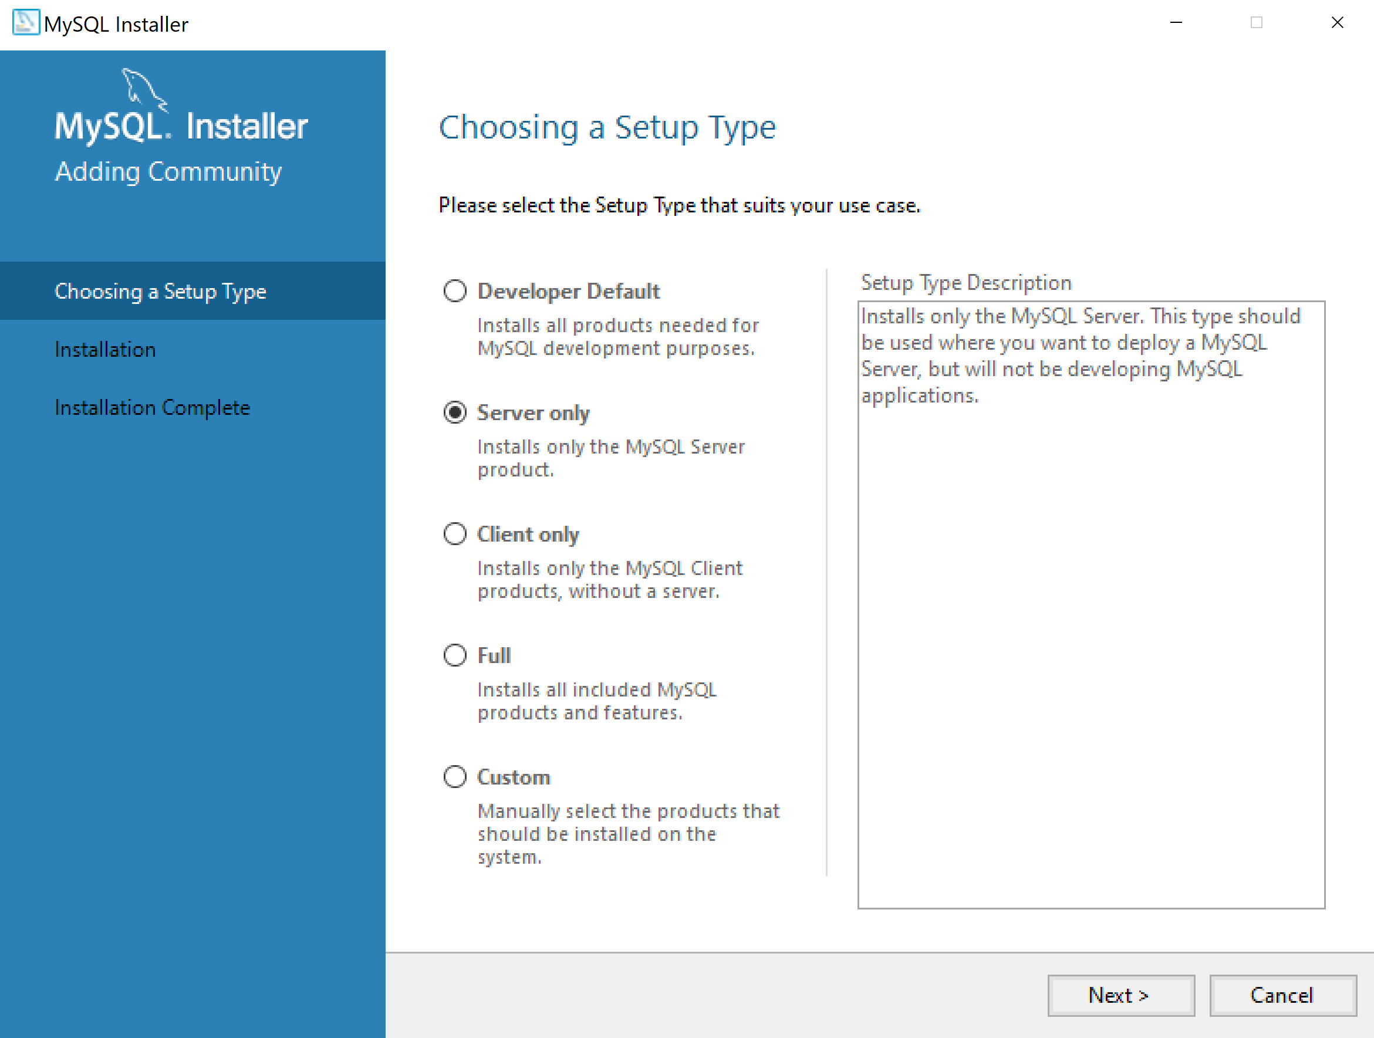

- When “Path Conflicts”, click “Next”

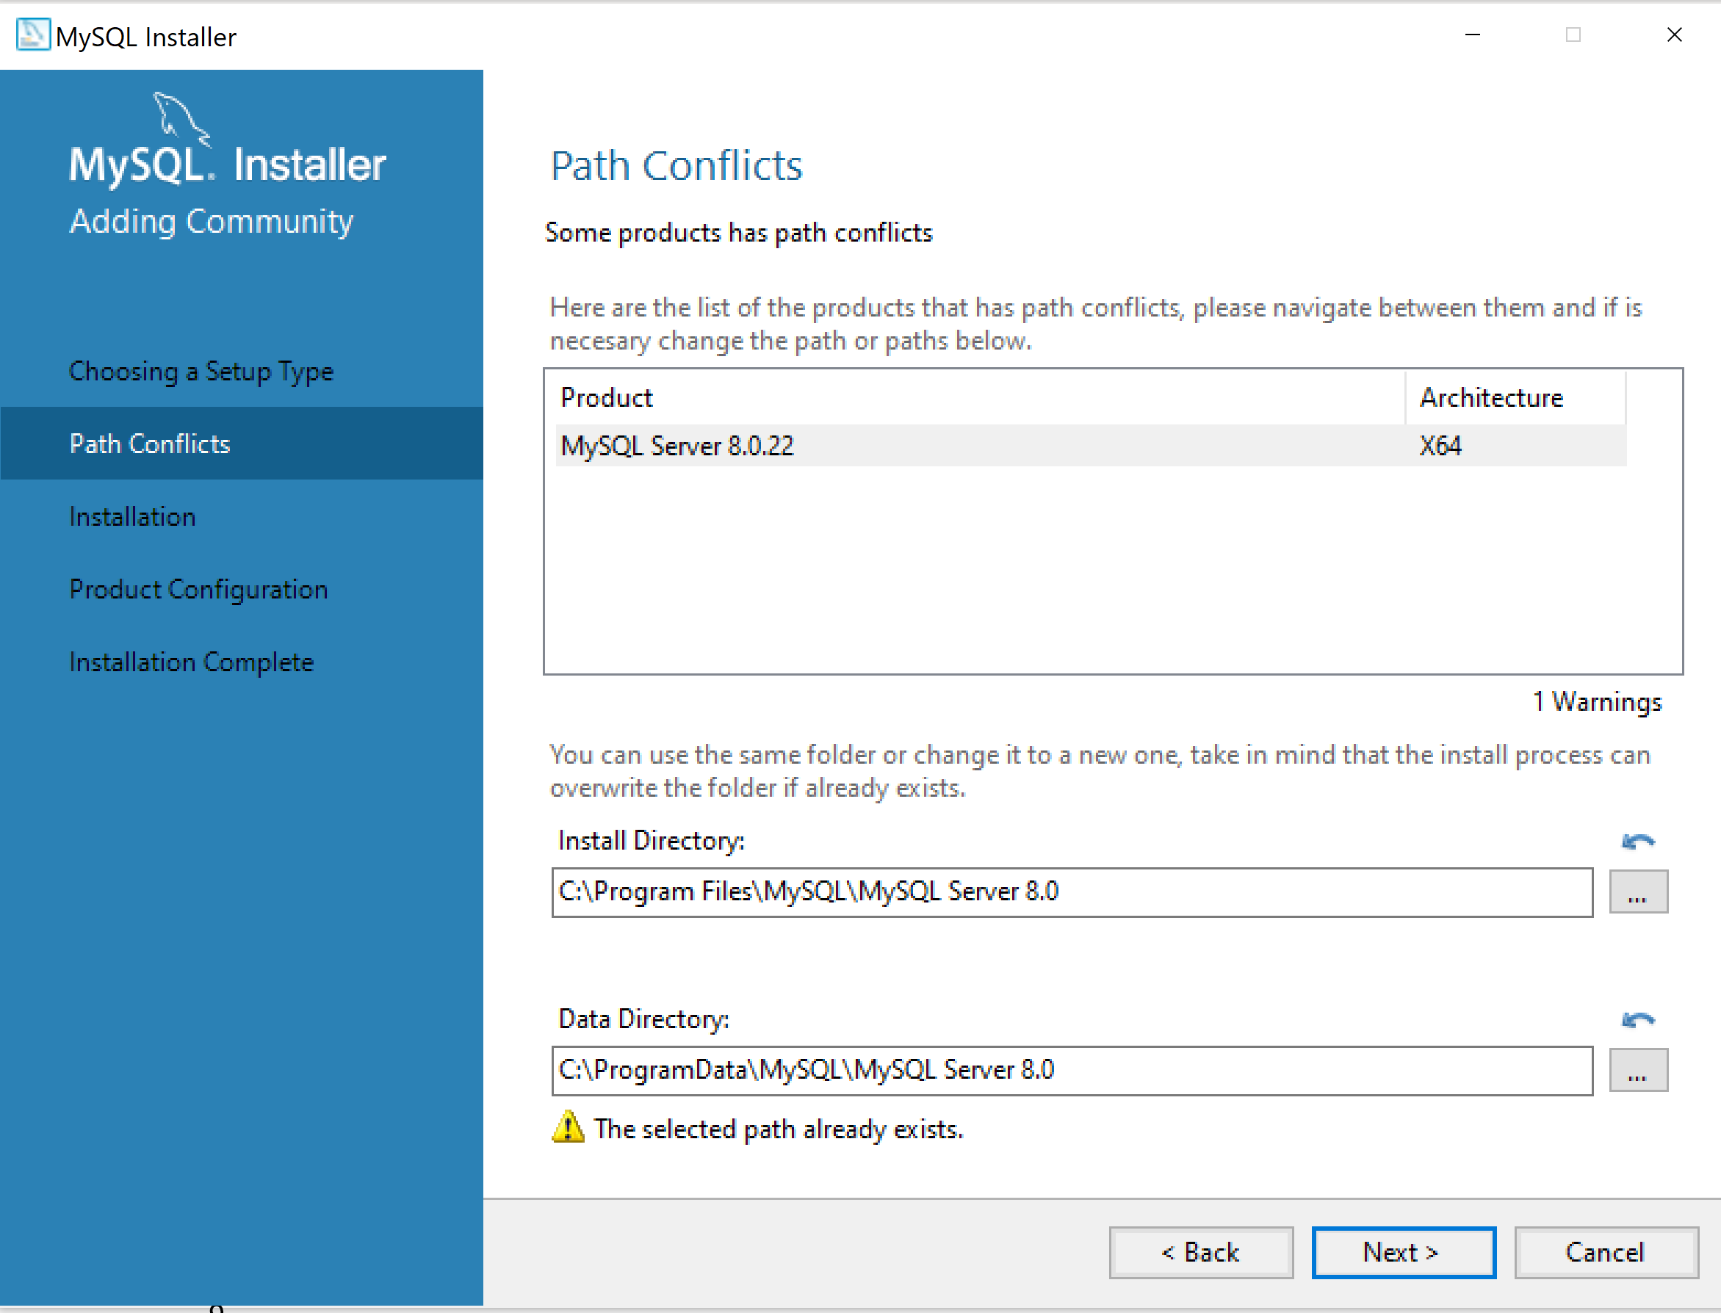

- Click “Execute” to install

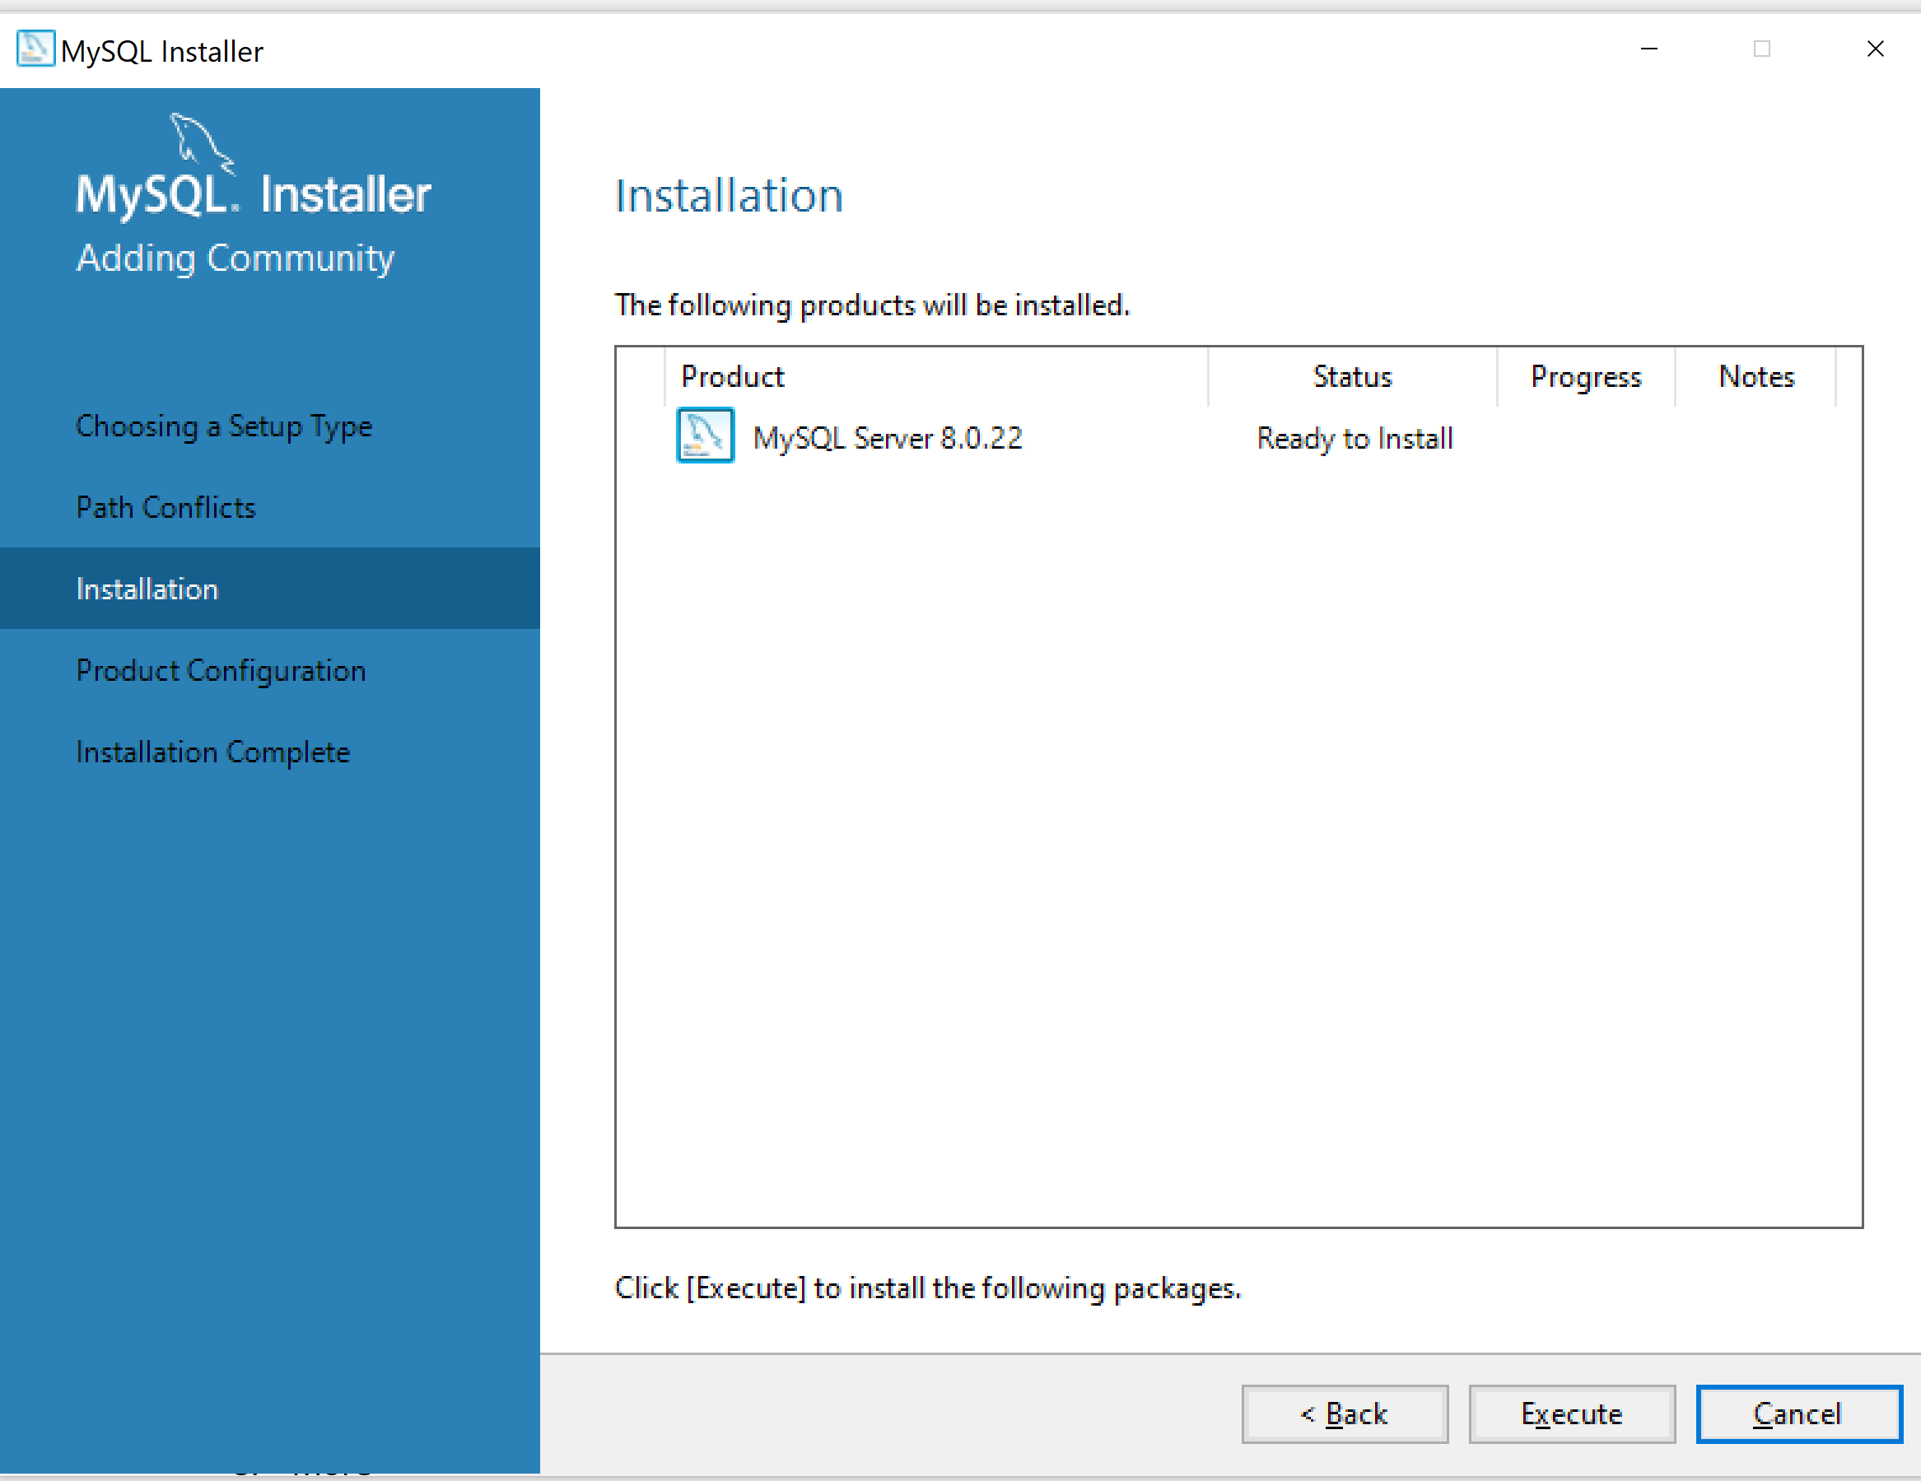

- Click “Next” to configure the product.

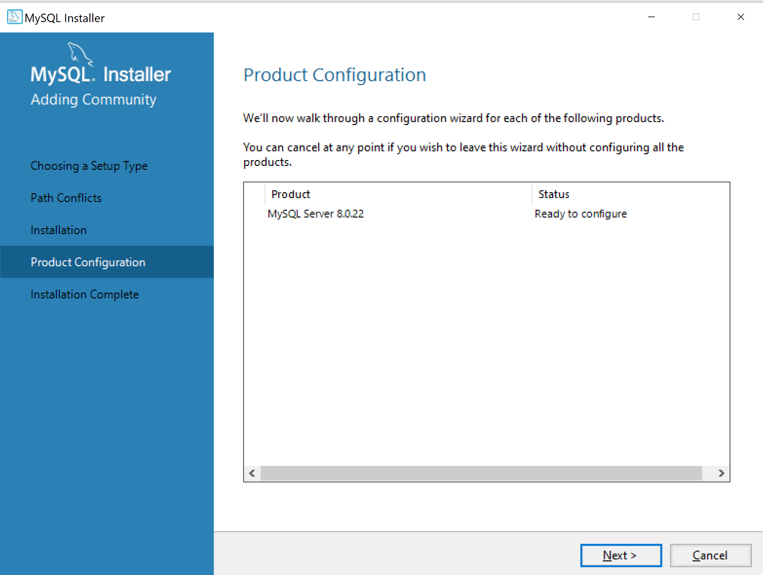

- Select “Server Computer” for Type and Networking

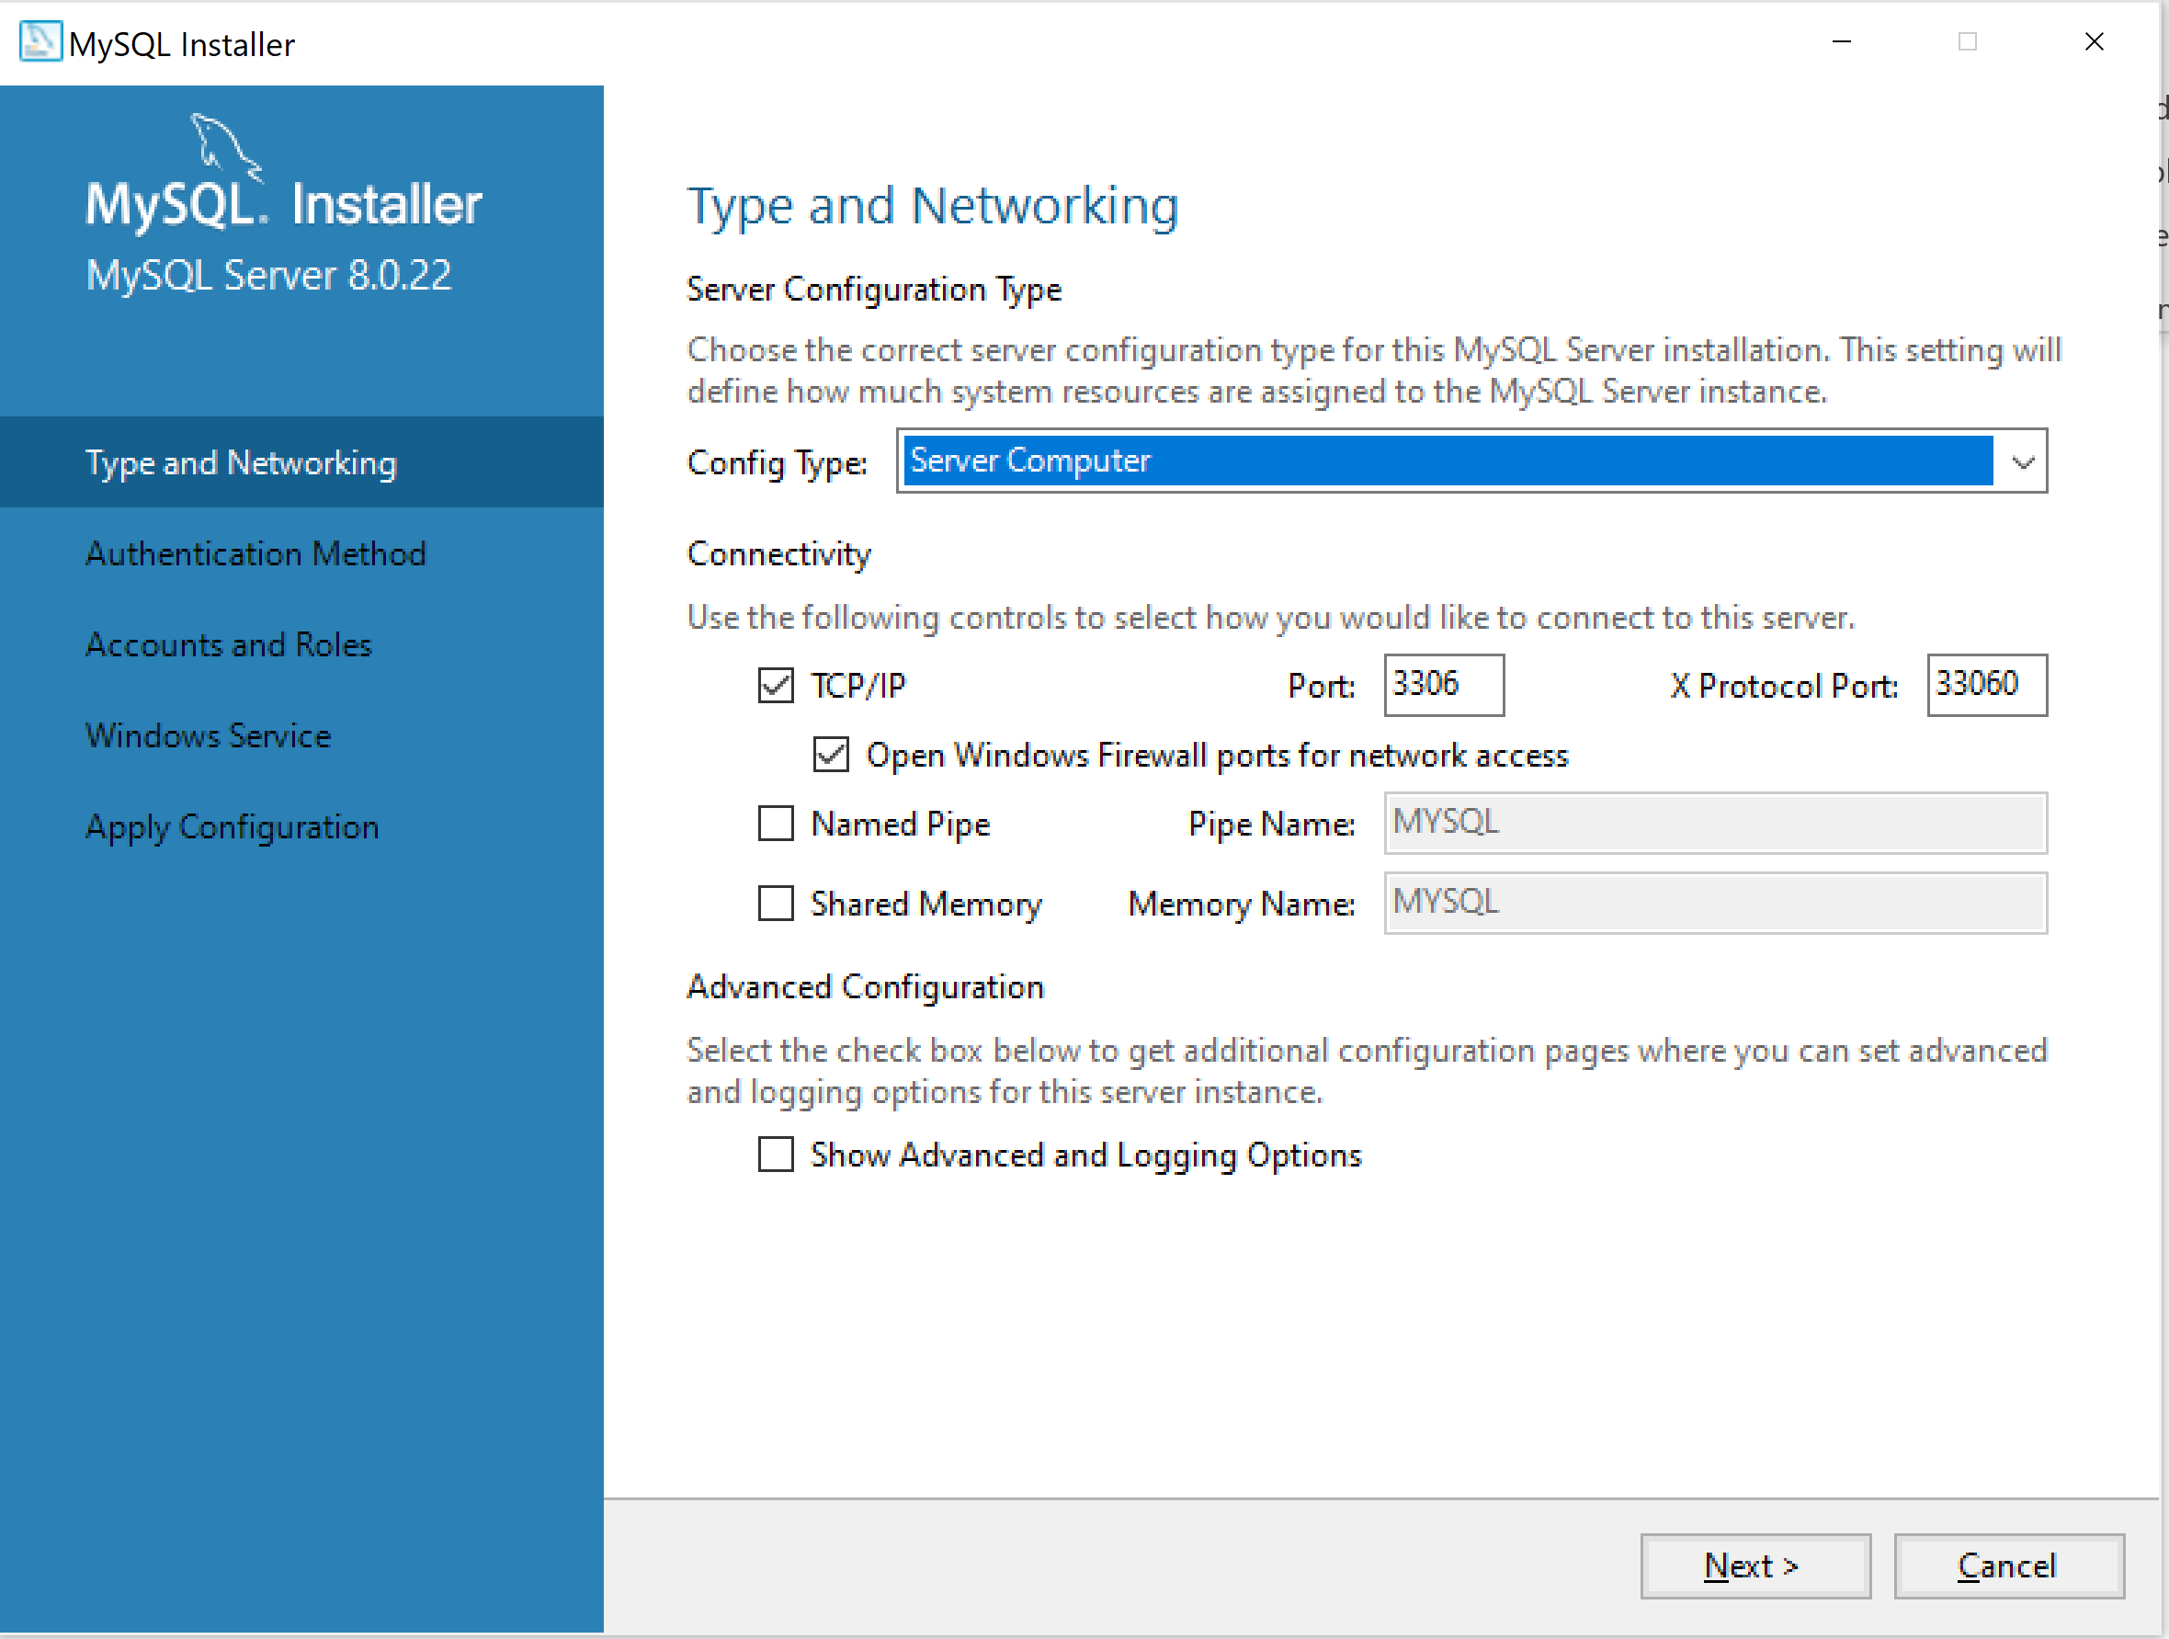

- Select “Use Strong Password Encryption for Authentication” for Authentication Method

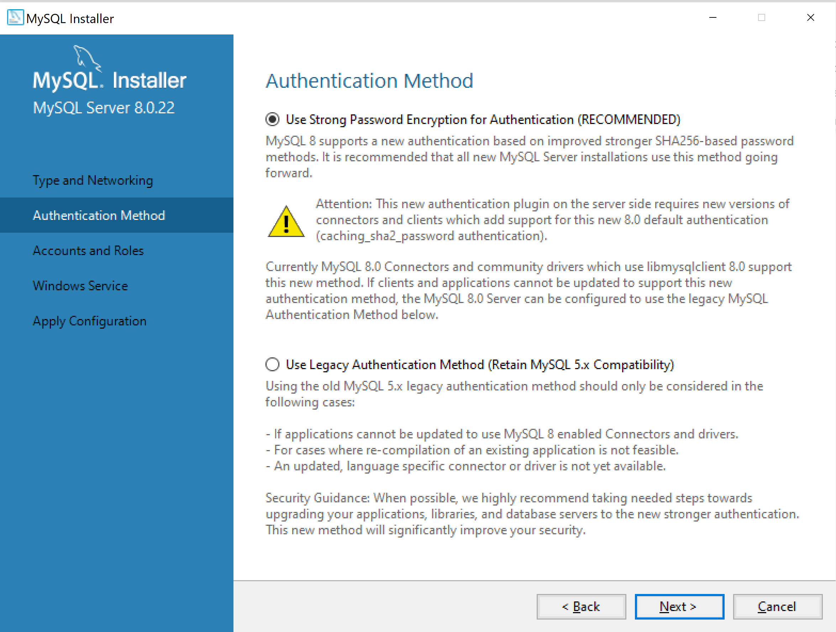

- Enter root password

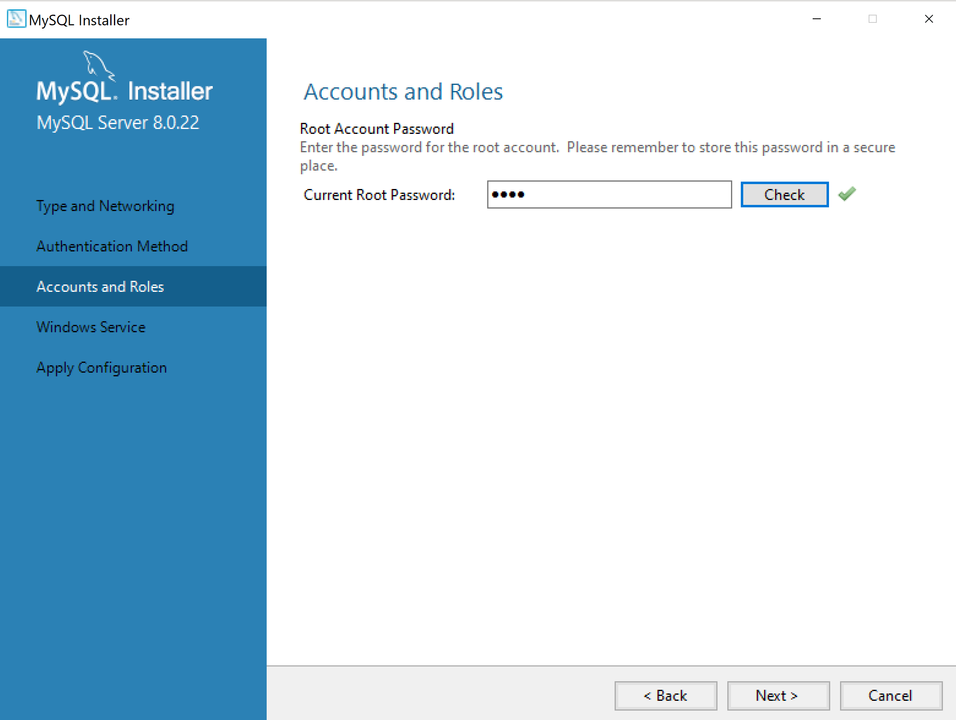

- Un-select “Start the MySQL Server at System Startup” so that you will start the service manually. (Correction: select Start the MySQL Server at System Startup)

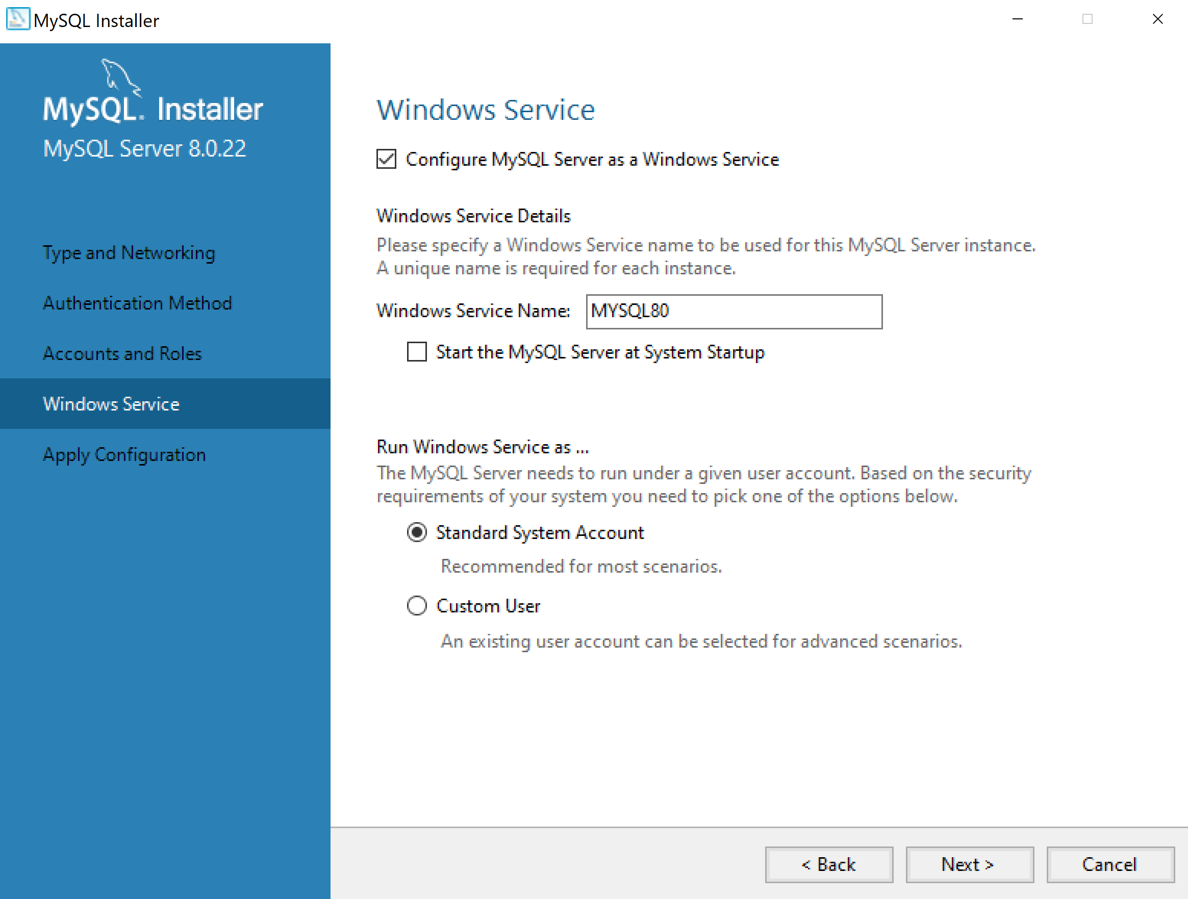

- Click “Execute” to apply the configuration

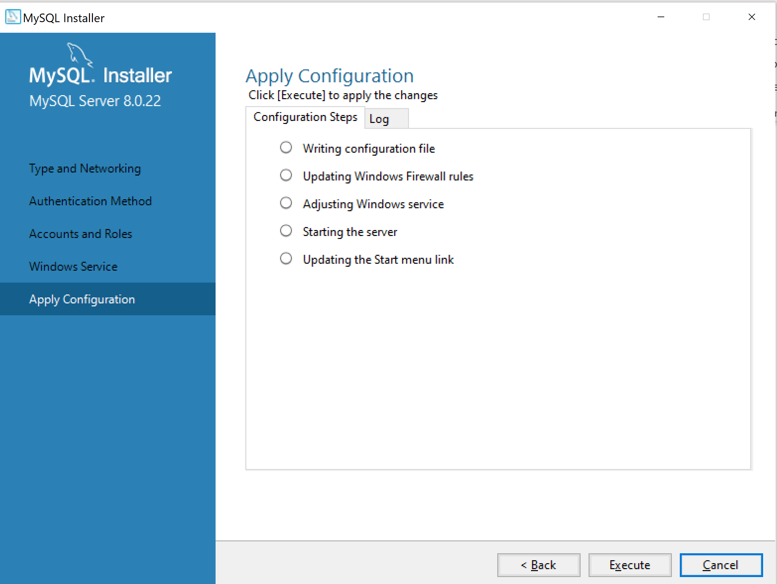

- Click “Finish” when complete

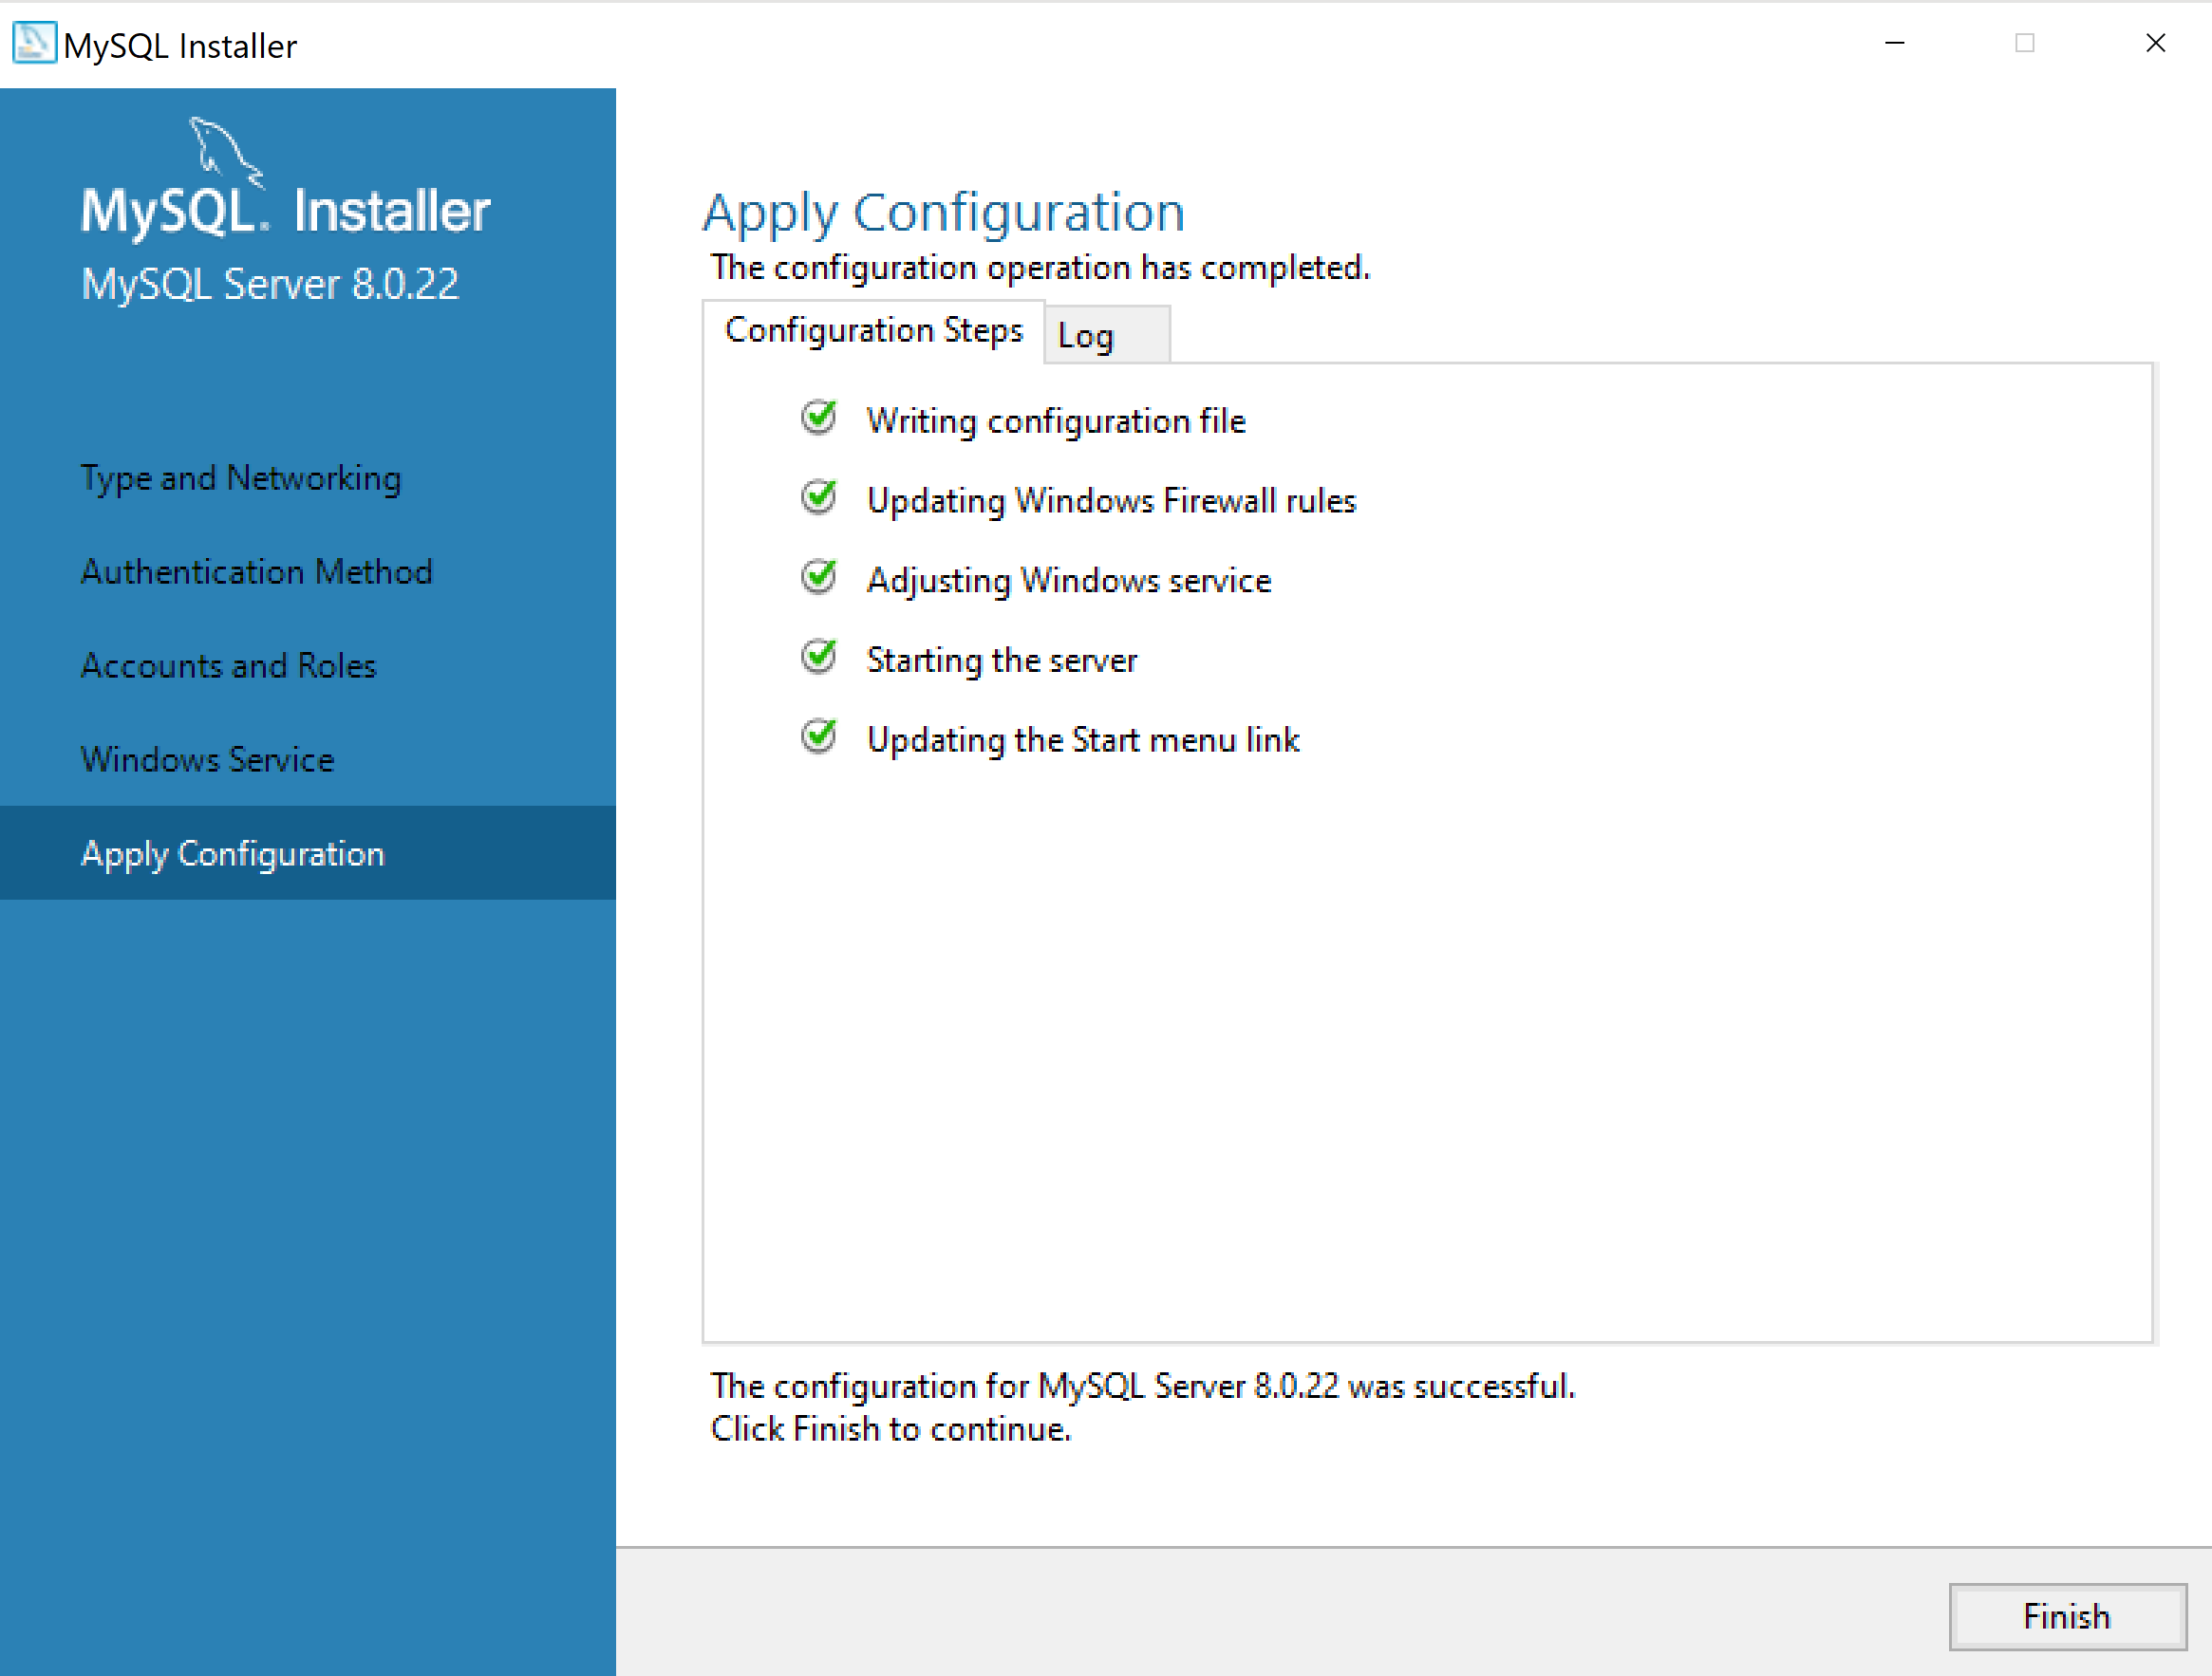

- Click “Next” for Product Configuration

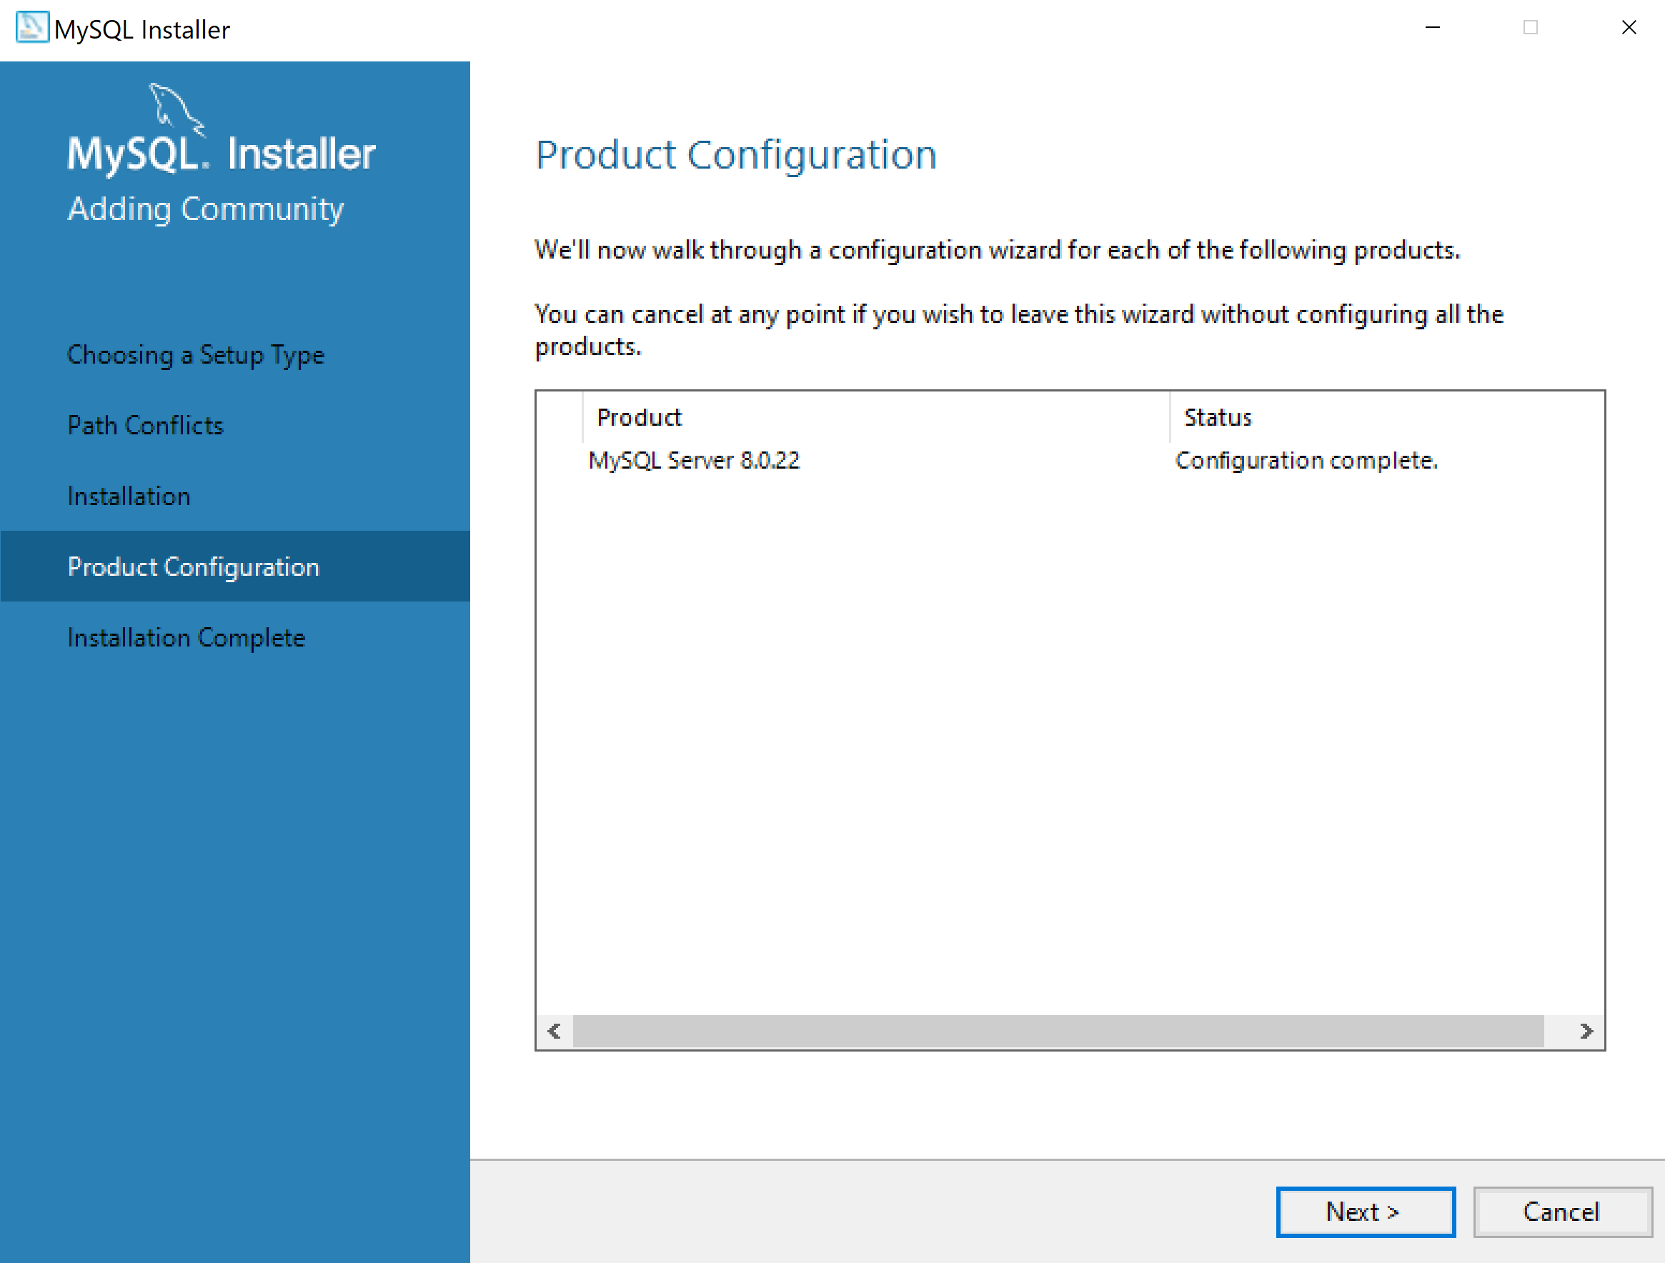

- Click “Finish” when done

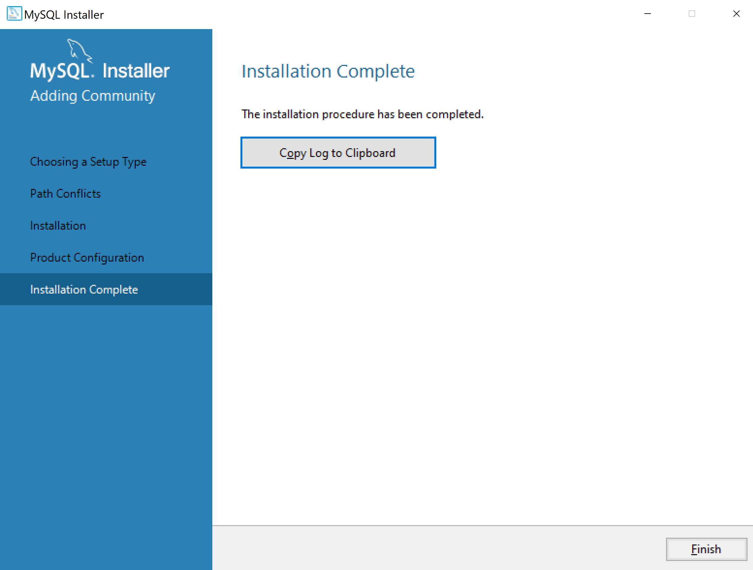

- Add mysql bin to your path. (See below appendix A)
- Start/Stop MySQL Database (See below appendix B)
- Then logon to MySQL Monitor (from CMD Window, issue the following command):
mysql -u root -p
PassWord

Appendix A
To edit the %path% variable:
- Type “path” in the Control Panel” search box

- From “Settings”, select “Edit environment variables for your account”
- Select “Advanced”, click “Environment Variables…”
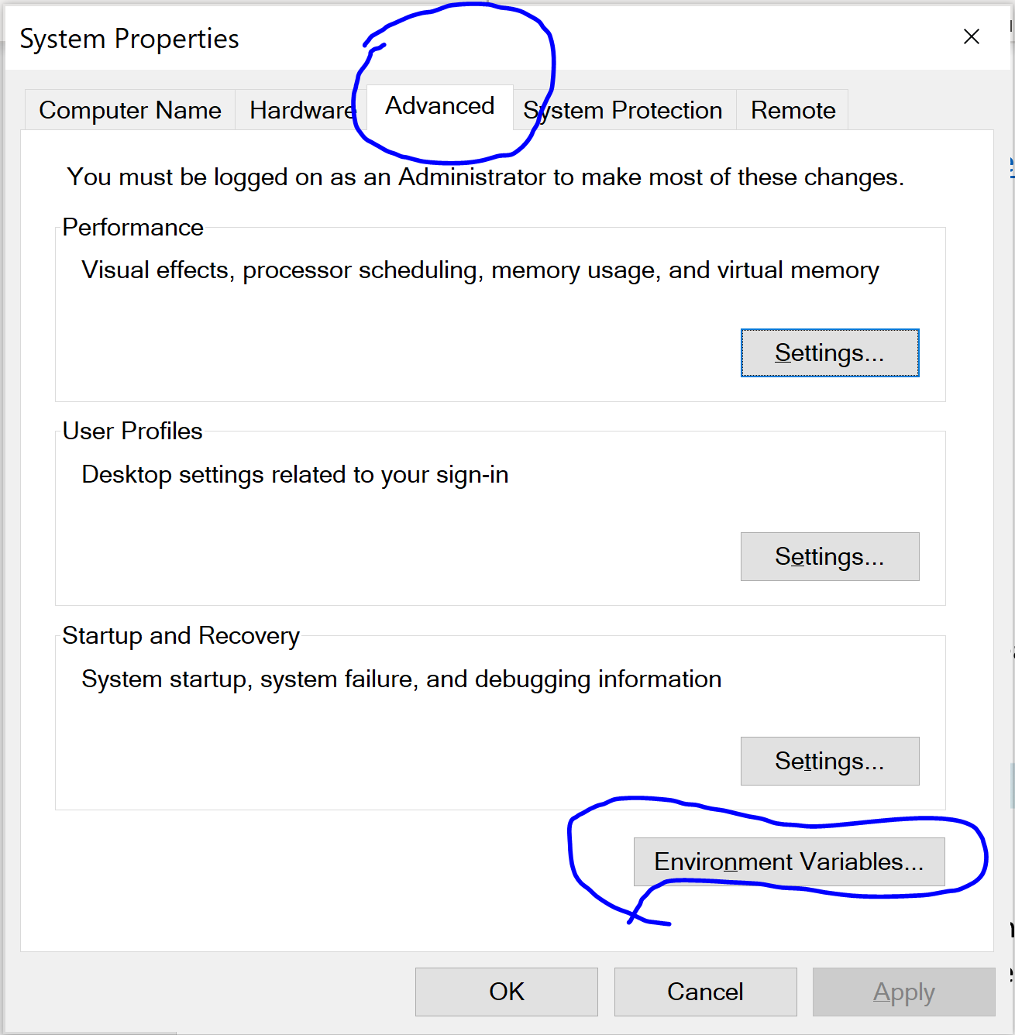

- From “System variables”, select “Path”, click “Edit…”
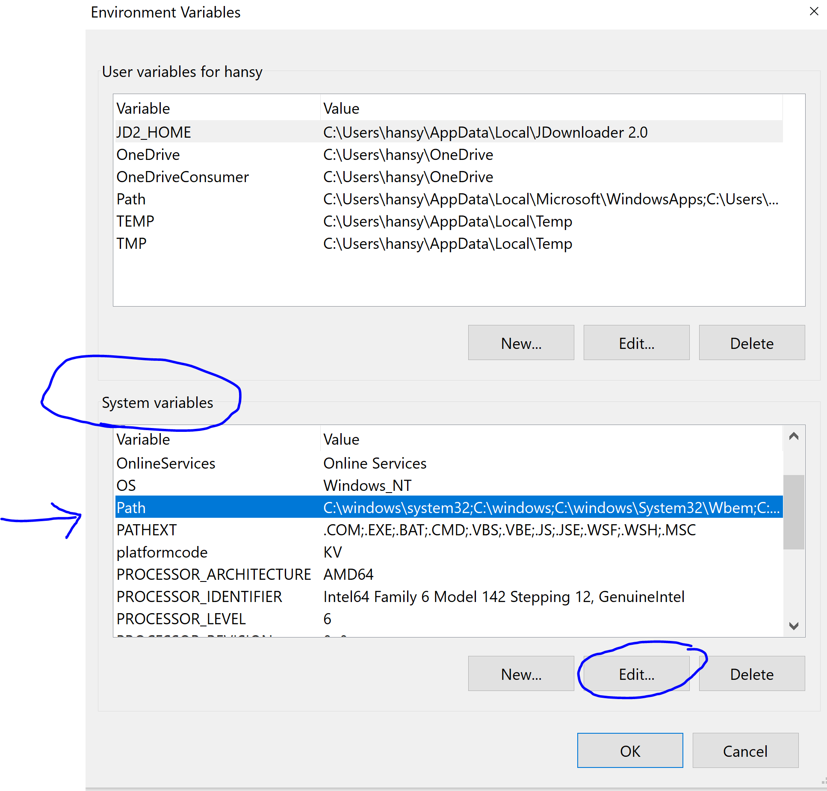

- Click “New” to add new entry, Enter your new entry, Click “OK” to complete.
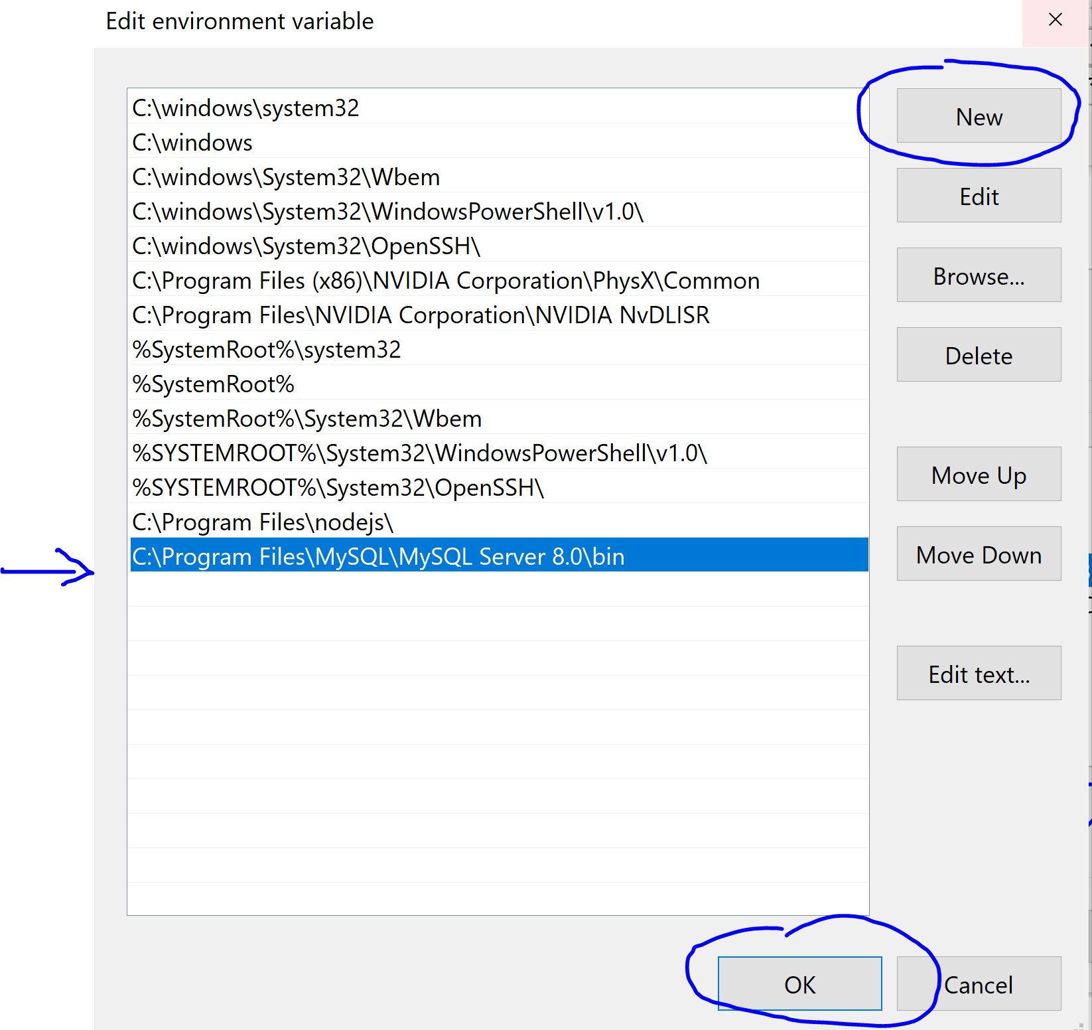

- Click “Edit” to modify the entry, and “OK” to complete.
- From cmd window, type “path” to make sure the above folder is in your path variable.

Appendix B
To Start/Stop MySQL DB:

Option 1:
To Start/Stop MySQL80 database (Windows 10):
Go to "Task Manager" (ctrl + alt + del)
Select "Services"
Look for "MYSQL80"
Right click, select "Start" (OR "Stop")

Option 2:
To Start/Stop MySQL80 database using command line (Windows 10):
Open "CMD" as Administrator
Enter "net start mysql80" (to start)
Enter "net stop mysql80" (to stop)
Then, logoff from "CMD", and logon as normal user using "CMD"

